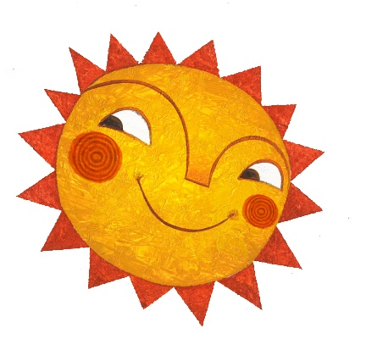
Summer Reading 2020
Reading Log

Name: | Library: Cahokia Public Library

Title and Author
1:
2:
3:
4:
5:
6:
7:
8:
9:
10:
11:
12:
13:
14:
15:
16:
17:
18:
19:
20:
21:
22:
23:
24:
25:
26:
27:
28:
29:
30:
