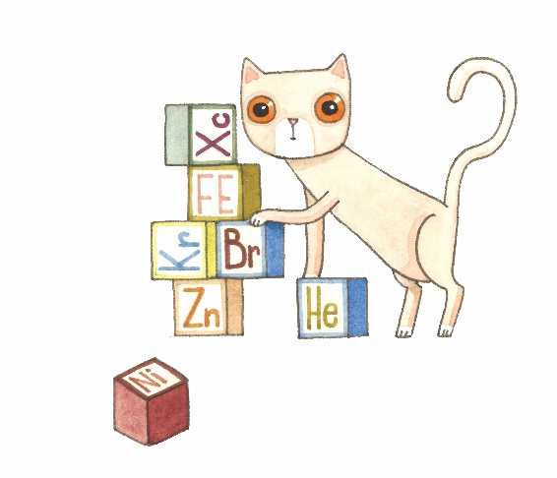
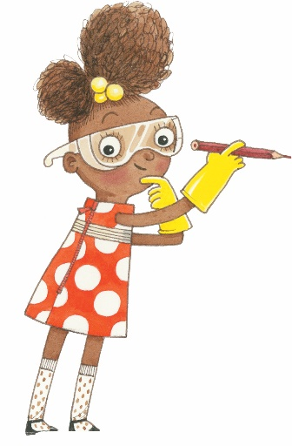
Summer Reading 2020
Activity Log
Week 6
Name: | Library: Cahokia Public Library
Complete all tasks in the week for a chance to win prizes! Bonus task give you an extra chance to win!
Monday | Introduction for Week 6 at noon with Ms. Val.  Schedule your time to pick up supplies  Hiding kangaroo | Completed?
Tuesday | Make the Kangaroo hide out by following  the instructions attached in packet. | Completed?
Wednesday | Virtual Storytime at noon check it out on our Facebook page!  You must tune in for credit. | Completed?
Thursday | Online Puzzle Game https://www.cbc.ca/kids/games/play/color-pipes | Completed?
Friday | Friday Science Day!  At home science project, use the instructions in your packets! | Completed?
Bonus | With your parent’s permission email the library a picture  of you doing a summer reading activity!  summerreading@cahokialibrary.org | Completed?

