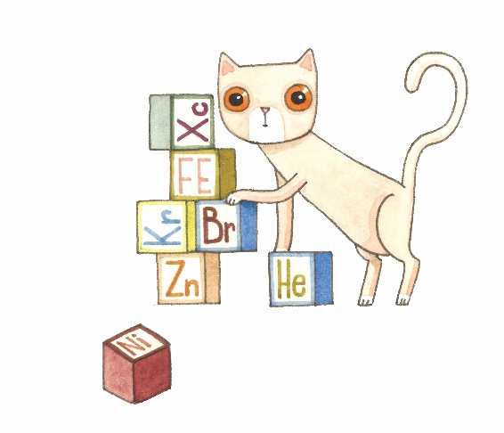
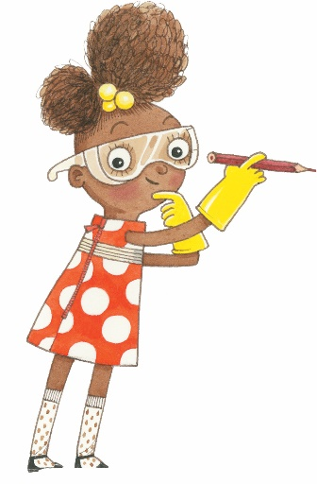
Summer Reading 2020
Activity Log
Week 1
Name: | Library: Cahokia Public Library
Complete all tasks in the week for a chance to win prizes! Bonus task give you an extra chance to win!
Monday | Summer Reading Kickoff with Miss Val; Come and  pick up Summer Reading Activity Bags | Completed?
Tuesday | Science Word Finds - See if you can find all the igneous rocks  and things in the rain forest (Online https://thewordsearch.com/puzzle/15945/the-rain-forest/ | https://thewordsearch.com/puzzle/59/types-of-igneous-rock/ or Print) | Completed?
Wednesday | Virtual Storytime --> Check it out on our Facebook page | Completed?
Thursday | Coloring Pages - Dinosaurs (Online https://www.online-coloring.com/coloring-page/tyrannosaurus-429.html | https://www.online-coloring.com/coloring-page/stegosaurus-herbivore-dinosaur-319.html or Print) | Completed?
Friday | Friday Science Day with Backyard Bingo  See if you can make a Bingo! (Bingo C on last page below) | Completed?
Bonus | With your parent’s permission email the library a picture  of you doing a summer reading activity!  summerreading@cahokialibrary.org | Completed?
